Floyd Warshall Algorithm

The Floyd-Warshall algorithm, named after its creators Robert Floyd and Stephen Warshall, is a fundamental algorithm in computer science and graph theory. It is used to find the shortest paths between all pairs of nodes in a weighted graph. This algorithm is highly efficient and can handle graphs with both positive and negative edge weights, making it a versatile tool for solving a wide range of network and connectivity problems.

Floyd Warshall Algorithm Algorithm:

step 1 : Initialize the solution matrix same as the input graph matrix as a first step.

step 2 :Then update the solution matrix by considering all vertices as an intermediate vertex.

step 3 :The idea is to pick all vertices one by one and updates all shortest paths which include the picked vertex as an intermediate vertex in the shortest path.

step 4 :When we pick vertex number k as an intermediate vertex, we already have considered vertices {0, 1, 2, .. k-1} as intermediate vertices.

step 5 :For every pair (i, j) of the source and destination vertices respectively, there are two possible cases.

* k is not an intermediate vertex in shortest path from i to j. We keep the value of dist[i][j] as it is.
* k is an intermediate vertex in shortest path from i to j. We update the value of dist[i][j] as dist[i][k] + dist[k][j], if dist[i][j] > dist[i][k] + dist[k][j]

**Illustration of Floyd Warshall Algorithm :**

*Suppose we have a graph as shown in the image:*

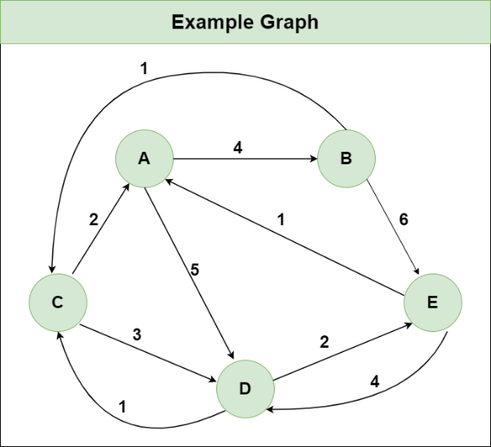

***Step 1:*** *Initialize the Distance[][] matrix using the input graph such that Distance[i][j]= weight of edge from* ***i*** *to* ***j****, also Distance[i][j] = Infinity if there is no edge from* ***i*** *to* ***j.***

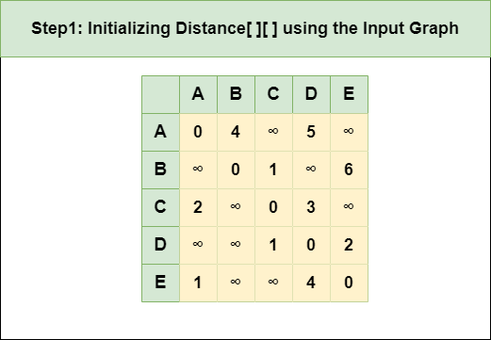

***Step 2****: Treat node* ***A*** *as an intermediate node and calculate the Distance[][] for every {i,j} node pair using the formula:*

*= Distance[i][j] = minimum (Distance[i][j], (Distance from i to* ***A****) + (Distance from* ***A*** *to j ))  
= Distance[i][j] = minimum (Distance[i][j], Distance[i][****A****] + Distance[****A****][j])*

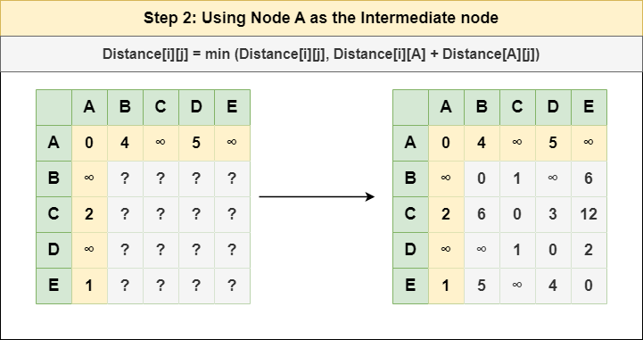

***Step 3****: Treat node* ***B*** *as an intermediate node and calculate the Distance[][] for every {i,j} node pair using the formula:*

*= Distance[i][j] = minimum (Distance[i][j], (Distance from i to* ***B****) + (Distance from* ***B*** *to j ))  
= Distance[i][j] = minimum (Distance[i][j], Distance[i][****B****] + Distance[****B****][j])*

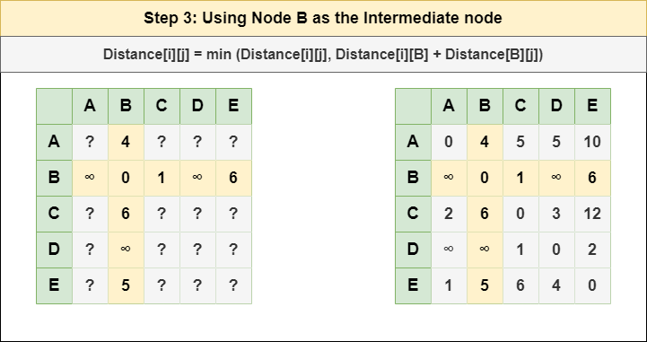

***Step 4****: Treat node* ***C*** *as an intermediate node and calculate the Distance[][] for every {i,j} node pair using the formula:*

*= Distance[i][j] = minimum (Distance[i][j], (Distance from i to* ***C****) + (Distance from* ***C*** *to j ))  
= Distance[i][j] = minimum (Distance[i][j], Distance[i][****C****] + Distance[****C****][j])*

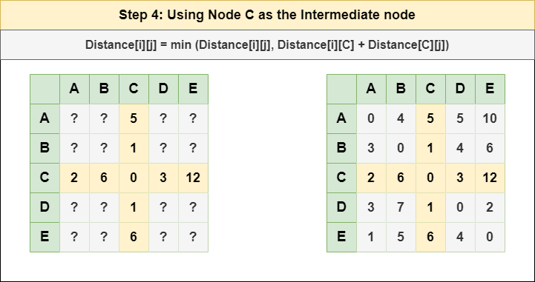

***Step 5****: Treat node* ***D*** *as an intermediate node and calculate the Distance[][] for every {i,j} node pair using the formula:*

*= Distance[i][j] = minimum (Distance[i][j], (Distance from i to* ***D****) + (Distance from* ***D*** *to j ))  
= Distance[i][j] = minimum (Distance[i][j], Distance[i][****D****] + Distance[****D****][j])*

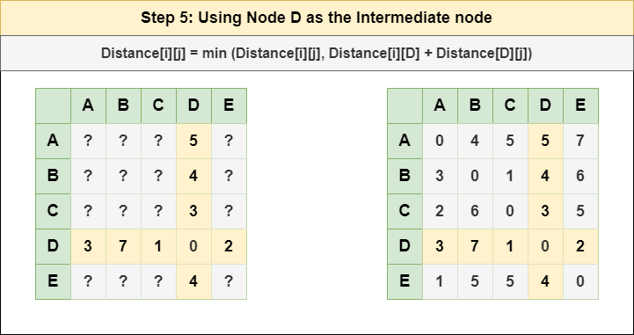

***Step 6****: Treat node* ***E*** *as an intermediate node and calculate the Distance[][] for every {i,j} node pair using the formula:*

*= Distance[i][j] = minimum (Distance[i][j], (Distance from i to* ***E****) + (Distance from* ***E*** *to j ))  
= Distance[i][j] = minimum (Distance[i][j], Distance[i][****E****] + Distance[****E****][j])*

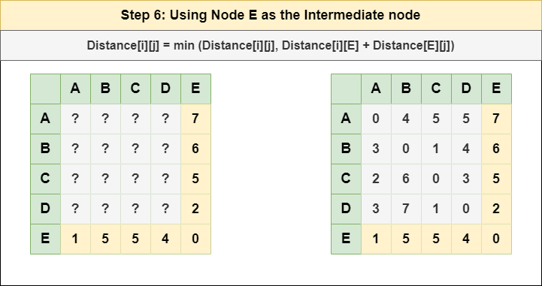

***Step 7****: Since all the nodes have been treated as an intermediate node, we can now return the updated Distance[][] matrix as our answer matrix.*

